1)

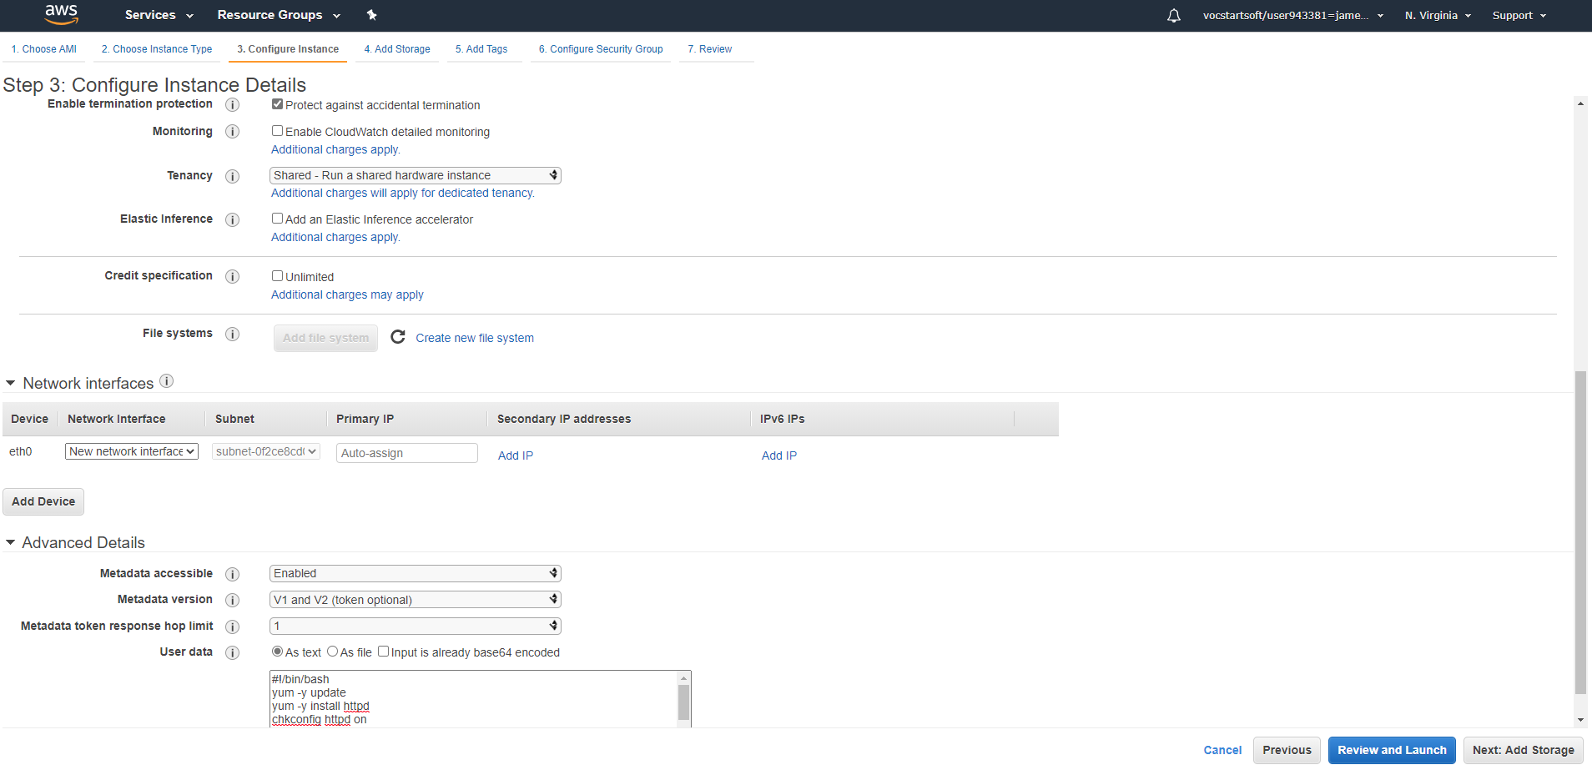  
  
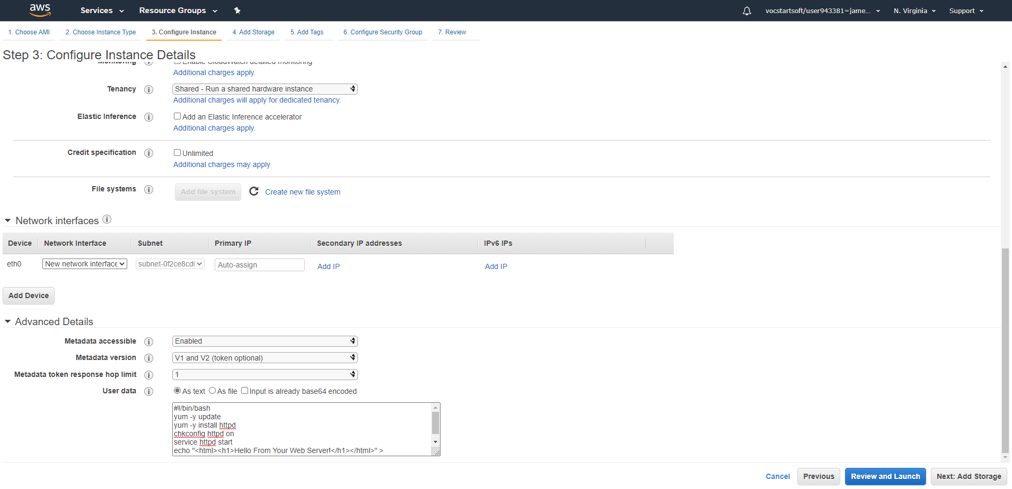

2) 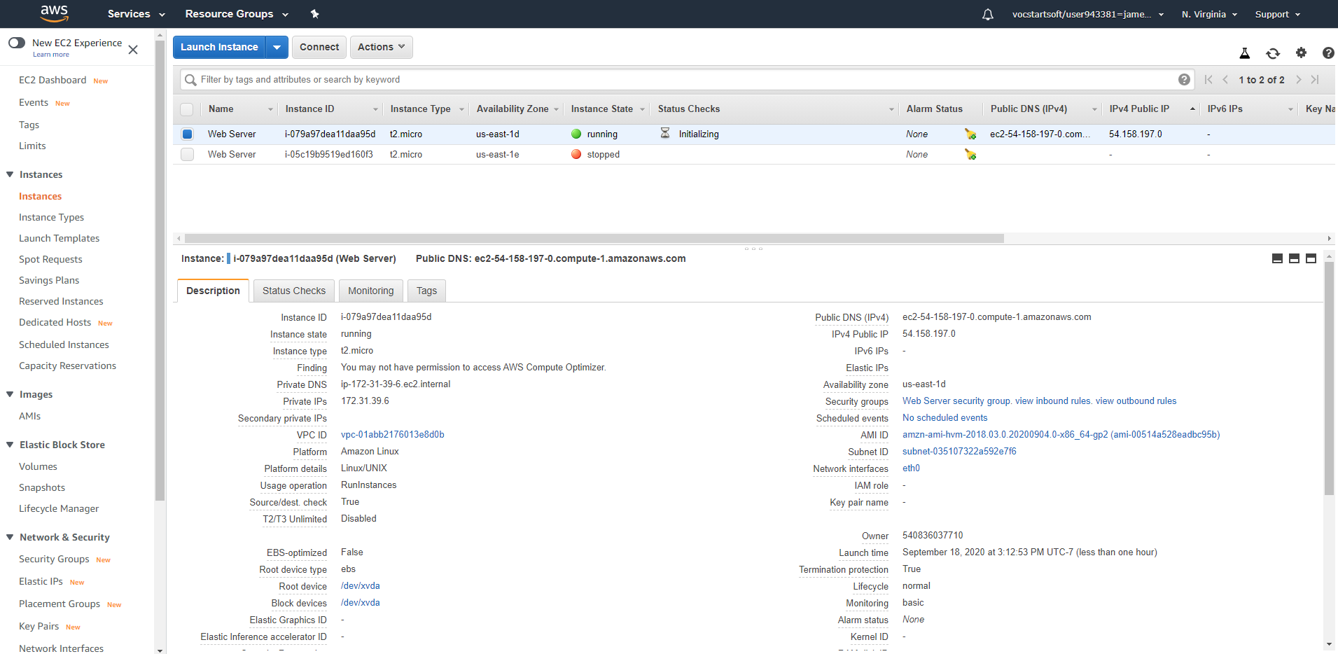

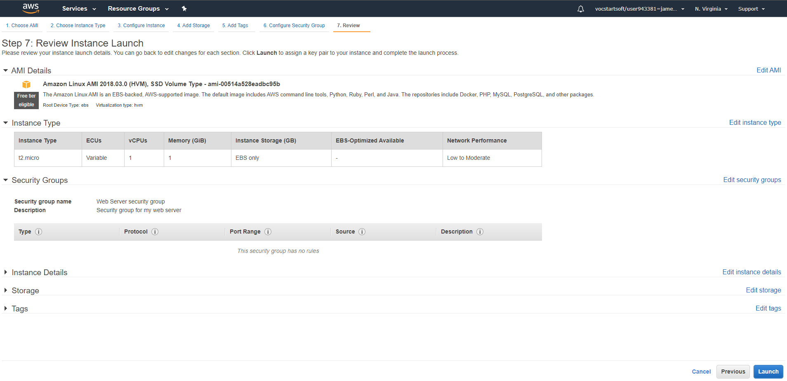

3)  
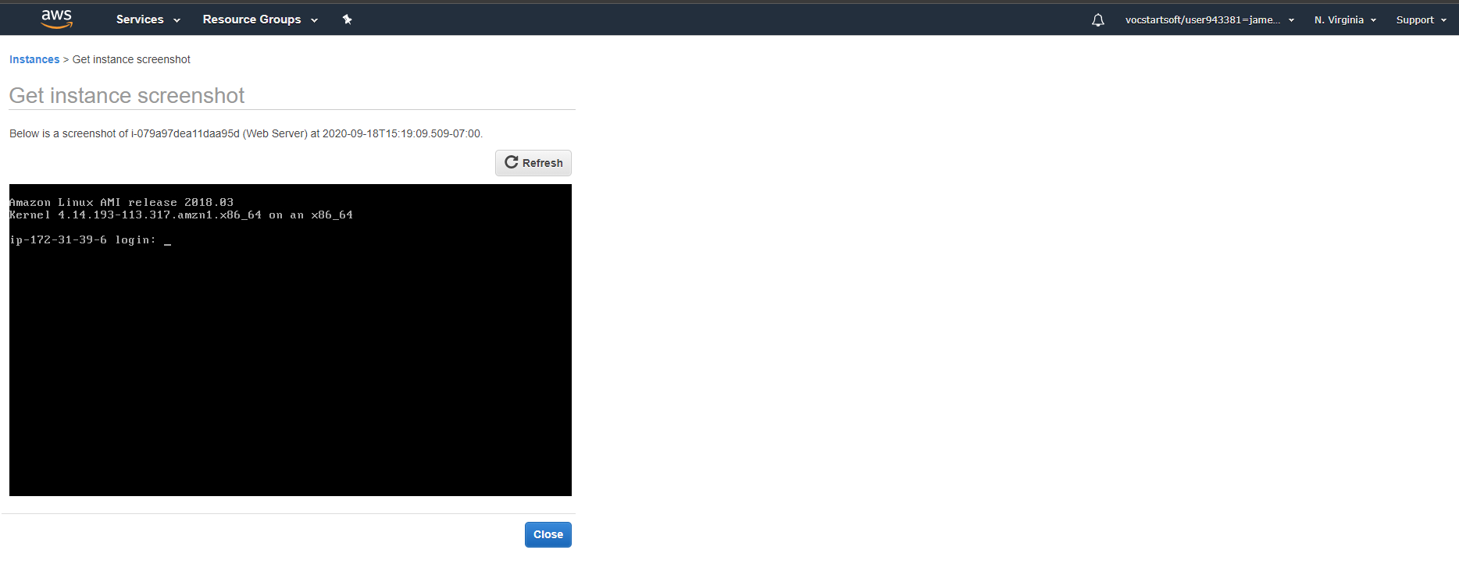

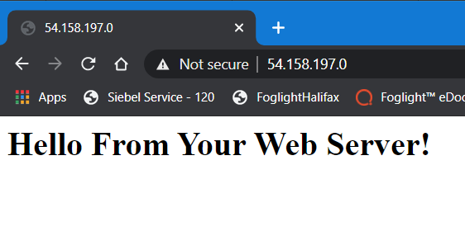

4)  
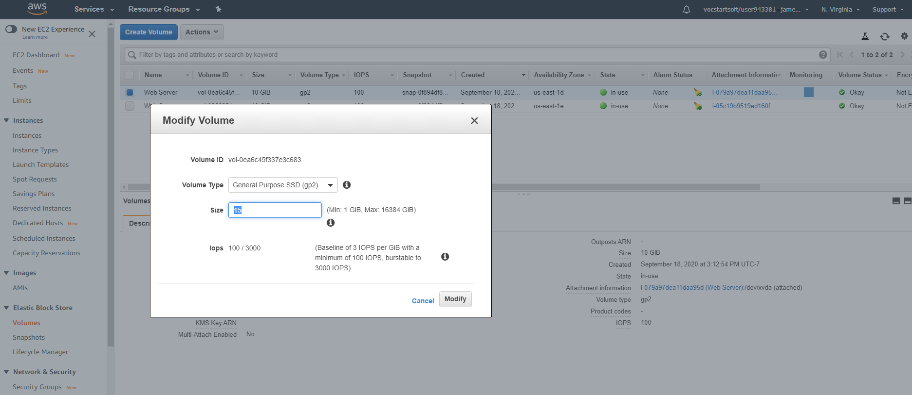  
  
I changed the 8g from initial setup to 10g because the first time, I was unable to modify the volume size. I checked the instance settings > get system log, I noticed space error messages. For some reason, I was not able to modify the volume. I started from scratch, now it works. I hope this is acceptable. I learned a lot on this lab. Thank you.

5)

